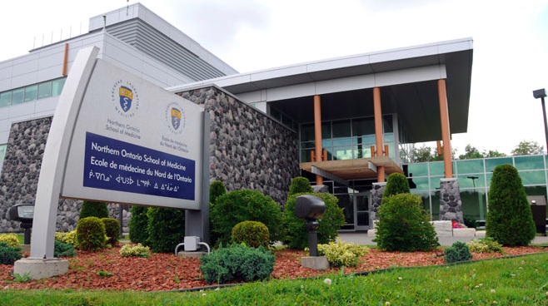

**Contact Information**

**Dr. Jason Shack**, Assistant Dean, Learner Affairs

Email: [jshack@nosm.ca](mailto:jshack@nosm.ca)

**Learner Affairs Offices**:

NOSM Lakehead (Thunder Bay), Room 2001 MS

NOSM Laurentian (Sudbury), Room 100A HSERC

Email: [learneraffairs@nosm.ca](mailto:learneraffairs@nosm.ca)

**Student Wellness Committee Chair:**

**Olivia Christie**, ochristie@nosm.ca  
  
Student Wellness Committee Contact:

***Northern Ontario School of Medicine***

**Learner Affairs Officers:**

**Cathy Schroeder**: [cathy.schroeder@nosm.ca](mailto:cathy.schroeder@nosm.ca)

**Laura Csontos**: [laura.csontos@nosm.ca](mailto:laura.csontos@nosm.ca)

**Sherry Mongeau**: [sherry.mongeau@nosm.ca](mailto:sherry.mongeau@nosm.ca)

Please follow this link for a list of available resources:

[www.nosm.ca/education/learner_affairs/default.aspx?id=21813](http://www.nosm.ca/education/learner_affairs/default.aspx?id=21813)

**Host Universities**

Lakehead University Student Health & Counseling (807)343-8361

[www.lakeheadu.ca/current-students/student-health-and-counselling-centre](https://www.lakeheadu.ca/current-students/student-health-and-counselling-centre)

Laurentian University Counseling & Support

(705)673-6506

<https://laurentian.ca/counselling-support>

Laurentian University Health and Wellness[www.laurentian.ca/health-wellness](http://www.laurentian.ca/health-wellness)

Need urgent support? <http://nosm.ca> and click:



**Northern Ontario School of Medicine**  
*Sudbury, Ontario*

*Thunder Bay, Ontario*

**

**Mental, Emotional and Spiritual Wellness**

**For All Distributed Learning Sites:**

**Shepell Student Assistance Program**

NOSM students and their dependent family members can access Shepell's resources.

**1-800-387-4765 (for service in English)**

**1-800-361-5676 (for service in French).**

You will be provided with the full access to face-to-face, telephonic, and e-counseling as well as resource kits and online services 24 hours a day, seven days a week. Website: [www.workhealthlife.com](http://www.workhealthlife.com)

**Physician Health Program (PHP)**

**Confidential Toll-Free line:** 1-800-851-6606 (in-province)

available 8:00 a.m. - 5:00 p.m. weekdays, [www.php.oma.org](http://www.php.oma.org)

**Mental Health Helpline**

1-866-531-2600

<http://www.mentalhealthhelpline.ca>

**Faith, Spirituality and Cultural Supports**

Lakehead Chaplaincy and Laurentian Spirituality Centres are available, as well as [**NOSM Indigenous Affairs**](http://www.nosm.ca/indigenous/) which can assist with connection to Elders and other Indigenous cultural supports

**Mental, Emotional and Spiritual Wellness**

Thunder Bay: Lakehead Student Health & Counselling Centre

Physicians available, appointments can be booked in advance

<https://www.lakeheadu.ca/current-students/student-health-and-counselling-centre/services-offered/medical-health-services>

#### Sudbury: Laurentian University Health Services

#### Offers primary healthcare, counselling and medical care. RN’s and NP’s on staff during regular office hours, part time physicians are available by appointment

#### <https://laurentian.ca/health-wellness>

**Fitness and Recreation**

NOSM campus athletic facilities and campus recreation:

Thunder Bay: [www.thunderwolves.ca/campus-rec/](http://www.thunderwolves.ca/campus-rec/)

Sudbury: [www.recreation.laurentian.ca](http://www.recreation.laurentian.ca)

GoodLife Fitness (discounted membership with OMA discount)

Please see the Clerkship Community Handbook for local resources and supports for each CCC community.

**Physical Wellness**

**Physical Wellness**

**You have brains in your head.**

**You have feet in your shoes.**

**You can steer yourself any direction you choose.**

**- Dr. Seuss**

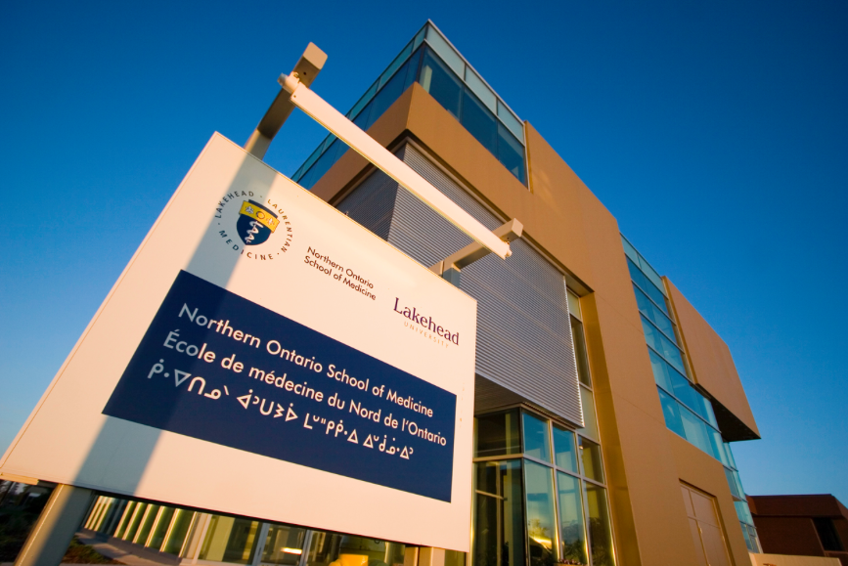

**Career Planning and Academic Support**

**Career Planning and Academic Support**

Learner Affairs provides ***Career on Track,*** a comprehensive 4 year plan to progressively assist you in career planning – knowing yourself, exploring options, choosing a specialty, and getting into residency

Individual career advising appointments are provided by the Learner Affairs Officers - Learner Affairs Officers: [cathy.schroeder@nosm.ca](mailto:cathy.schroeder@nosm.ca); [laura.csontos@nosm.ca](mailto:laura.csontos@nosm.ca) and [sherry.mongeau@nosm.ca](mailto:sherry.mongeau@nosm.ca)

**Faculty Mentoring Program –** The Faculty Mentor program through Learner Affairs connects undergraduate learners with faculty who can serve as physician mentors. Group sessions and Faculty Round Robin evenings introduce students to the different specialties.

NOSM Student Society Interest Groups also provide a wonderful opportunity to connect with physicians and residents to help inform students about various specialties

***Northern Ontario School of Medicine***

**Study Spaces**

**NOSM Health Sciences Libraries**: great study spaces and online resources

Students also have access to Lakehead libraries (Chancellor Patterson, Education Library) and Laurentian library (J.N. Demarais library).

NOSM group rooms are popular study places from for students with 24/7 key card access when not booked for classes.

Learner Affairs can assist with information and support to be successful, including assistance with requests for academic accommodation.

**Sudbury Coffee Shops: Thunder Bay Coffee Shops:**

Salute (two locations) Sweet North Bakery

Kuppajoe St. Paul’s Roastery

Old Rock (two locations) International House of Tea

Starbucks Bean Fiend Cafe

Pinchman’s Calico Coffeehouse

**Academic Secrets to Success**

**Sudbury**

Digusto’s

Laughing Buddha

Respect is Burning

Tommy’s Not Here

Tuco’s Tacos

Ripe

**Thunder Bay**

The Sovereign Room

Madhouse

Hoito

Tokyo House

The Growing Season

Tomlin

**Where to eat**

(insert photo here)

**Highlights and Extras**

SUDBURY ACTIVITIES

Lake Laurentian Conservation Area

Killarney Provincial Park

Kivi Park

Bell Park

Onaping Falls

THUNDERBAY ACTIVITIES

Cascade Conservation Area

Mount McKay Scenic Lookout

Kakabeka Falls Provincial Park

Eagle Canyon Suspension Bridge

Sleeping Giant Provincial Park

Ouimet Canyon

Thunder Bay Country Market

***Northern Ontario School of Medicine***

**NOSM Student Wellness Committee**

Olivia Christie- Chair

Talia Ryan- 4th Year Representative

Stephanie Lachapelle - 3rd Year Representative

Lindsay Leduc- 2nd Year Representative

Jennifer Hammell- 2nd Year Representative

Bradley Rietze- 1st Year Representative

Dayna Ingves- 1st Year Representative

